Olerup SSP®

PHOTO DOCUMENT

Olerup SSP® HLA-B low resolution

Prod. No: 101.501-48/48u
101.501-12/12u
Lot No: 54R
Expiry Date: 2015-May-01

Name:________________Sample ID:_______________

DNA Extract Date:_________ Conc.(ng/ul):_________

Test Date: _________Review Date:_______________

Tested By: _________Reviewed By:_______________

Interpretation:_________________________________

Specificities and sizes of the PCR products of the 63+1 primer mixes used for HLA-B low resolution SSP typing.

Primer Mix | Size of spec. PCR product¹ | Size of control band² | HLA-B  serol.³ | Amplified HLA-B alleles^{4,5}
1^{6,9} | 110 bp | 800 bp | 7, 703, 40, 41, 42, 48, 61 | *07:02:01-07:18:02, 07:20-07:32, 07:34-07:39, 07:41-07:47, 07:49N-07:50, 07:52, 07:54-07:59, 07:61-07:99, 07:101-07:121, 07:123-07:138, 07:140-07:154, 07:156-07:162, 08:79, 15:138, 15:230, 15:241, 37:07, 40:15-40:16, 40:23, 40:32, 40:98, 40:136, 40:158, 40:183, 40:198, 41:08, 42:05:01-42:05:02, 44:150, 48:05, 48:08, 48:15, C*02:23, C*04:77
2 | 215 bp | 1070 bp | 8, 44 | *08:01:01-08:05, 08:07-08:25, 08:27-08:49, 08:51-08:61, 08:63-08:64, 08:66-08:84, 08:86N-08:93, 15:142, 15:180, 44:49, 51:68
3 | 140 bp, 235 bp | 1070 bp | 7, 8, 13, 15, 35, 4005, 44, 49, 61, 62, 77 | *07:20, 07:24, 07:60, 07:100, 07:131, 08:21, 08:25, 13:01:01-13:04, 13:06-13:08Q, 13:10-13:23, 13:25-13:38, 13:40-13:57, 15:07:01-15:07:02, 15:36^{w}, 15:45, 15:55, 15:68, 15:89^{w}, 15:126, 15:207, 35:05:01-35:05:03, 35:16-35:17, 35:22, 35:30, 35:51, 35:58, 35:72, 35:89, 35:97, 35:113-35:114, 35:125, 35:164, 35:199, 40:05, 40:71, 40:174, 44:08^{w}, 44:54, 44:57^{w}, 44:60, 44:106, 44:110, 44:135, 46:12, 51:64, 53:14, 55:51, 58:18, C*03:05, C*03:25, C*03:27, C*03:143
4^{7,8,16} | 130 bp, 265 bp | 800 bp | 12, 13, 14, 17, 21, 35, 40, 41, 44, 45, 47, 49, 50, 60, 61, 64, 65 | *13:01:01-13:04, 13:06-13:13, 13:15-13:23, 13:25-13:57, 14:01:01-14:04, 14:07N, 14:09, 14:11-14:12, 14:14-14:32, 15:46, 15:53, 15:106, 15:212, 18:44:01-18:44:02, 35:46-35:47, 35:63, 35:154, 40:01:01-40:01:25, 40:07, 40:10:01-40:10:02, 40:14:01-40:16, 40:22N-40:23, 40:25, 40:30-40:34, 40:36, 40:38, 40:42-40:43, 40:45, 40:47-40:49, 40:51-40:55, 40:58-40:63, 40:65-40:67, 40:69, 40:72:01-40:73, 40:76-40:77, 40:79-40:81, 40:84, 40:87:01-40:88, 40:92, 40:100-40:102, 40:106, 40:108, 40:110, 40:112-40:114, 40:116-40:118N, 40:121, 40:123-40:126, 40:128-40:130, 40:132, 40:134-40:136, 40:139-40:141, 40:146-40:147, 40:150-40:156, 40:158, 40:160:01, 40:163-40:164, 40:166, 40:168, 40:171-40:172, 40:175, 40:178-40:179, 40:182-40:183, 40:186-40:188, 40:191-40:199, 40:204, 40:207-40:208, 40:212-40:213, 40:215, 41:01-41:21, 44:02:01:01-44:03:06, 44:03:08-44:03:15, 44:04-44:05:04, 44:09-44:39, 44:41:01-44:43:02, 44:45-44:56N, 44:58N-44:80, 44:82, 44:84-44:102, 44:104-44:110, 44:112-44:129, 44:132-44:133, 44:135-44:144, 44:146-44:155, 45:01-45:14, 47:01:01:01-47:08, 49:01:01-49:02, 49:04-49:22, 50:01:01-50:02, 50:04-50:06, 50:08-50:17, 57:45, 57:51, C*01:30
5⁸ | 185 bp, 235 bp | 800 bp | 7, 16, 17, 27, 2708, 37, 38, 3901, 3902, 39, 64, 67 | *07:02:32, 14:01:01-14:01:02, 14:07N-14:08, 14:10, 14:12, 14:14, 14:19, 14:26, 14:32, 27:01-27:05:15, 27:05:17-27:06, 27:08-27:10, 27:12-27:13, 27:16-27:18, 27:20, 27:23, 27:26-27:27, 27:29, 27:31, 27:35-27:37, 27:39-27:42, 27:44-27:46, 27:48-27:61, 27:64N-27:69, 27:72-27:75, 27:77-27:80, 27:82-27:92, 37:02, 38:01:01-38:02:02, 38:03, 38:07-38:24, 38:26-38:32, 38:34N-38:40, 39:01:01:01-39:01:01:03, 39:01:03-39:01:08, 39:01:10-39:02:01, 39:03, 39:05:01-39:09, 39:11, 39:14-39:15, 39:18, 39:19:02, 39:22, 39:24:01-39:39:01, 39:40:01N-39:44, 39:46-39:48, 39:50-39:62, 39:64-39:71, 39:73-39:75, 47:04-47:05, 48:21, 48:26, 67:01:01, 67:03
6 | 190 bp | 800 bp | 14, 35, 38, 39, 65 | *07:28, 08:87, 14:02:01-14:02:02, 14:02:04-14:02:05, 14:02:07-14:06:02, 14:09, 14:11, 14:13, 14:15-14:18, 14:20, 14:22-14:23, 14:25, 14:27, 14:29-14:31, 15:77, 15:189, 15:233, 35:26, 38:05, 38:33, 39:04, 44:16, 44:37:01-44:37:02, 44:64:01-44:64:02, 44:91, 44:132, 44:150, 52:26, 57:04, A*23:31, A*24:106, C*07:231, C*16:10
7 | 290 bp | 1070 bp | 15, 22, 62, 63, 71, 72, 75, 76, 77, 46 | *15:01:01:01-15:01:03, 15:01:06-15:02:06, 15:03:03-15:08, 15:10:02-15:11:03, 15:11:05-15:15, 15:17:01:01-15:17:02, 15:19-15:21, 15:24-15:28, 15:30-15:36, 15:38:01-15:40, 15:42-15:46, 15:48, 15:50, 15:55-15:58, 15:60, 15:63, 15:65-15:66, 15:70-15:71, 15:73, 15:75-15:79N, 15:81-15:89, 15:92, 15:94N, 15:96-15:97, 15:101-15:102, 15:104-15:107, 15:109-15:113, 15:116-15:118, 15:120-15:122, 15:125-15:126, 15:128-15:129, 15:135-15:150, 15:152, 15:154-15:155, 15:157, 15:159-15:160, 15:162-15:172, 15:174-15:175, 15:177-15:179, 15:181N-15:185, 15:187-15:196, 15:199, 15:201-15:209N, 15:211, 15:213-15:219, 15:223-15:225, 15:227-15:228, 15:230-15:234, 15:236-15:237, 15:239-15:241, 15:244-15:251, 46:01:01-46:34, C*01:73, C*07:02:30, C*08:16:02
8 | 165 bp, 220 bp, 330 bp | 1070 bp | 5, 8, 12, 21, 22, 37, 41, 42, 44, 45, 48, 51, 56, 57, 60, 62, 70, 71, 72, 82 | *08:01:01-08:05, 08:08N-08:12:03, 08:15-08:19N, 08:21-08:24, 08:26-08:27, 08:29-08:36, 08:38-08:39, 08:41-08:48, 08:50-08:54, 08:56:01-08:69,  08:71-08:73, 08:75-08:76, 08:78, 08:80-08:86N, 08:88, 08:90-08:94, 13:46, 15:03:01-15:03:03, 15:09-15:10:02, 15:18:01-15:18:04, 15:23, 15:29, 15:37, 15:46-15:47:02, 15:49, 15:51-15:54, 15:61-15:62, 15:64:01, 15:69, 15:72, 15:74, 15:80, 15:83, 15:90-15:91, 15:93, 15:98-15:99, 15:103, 15:106, 15:108, 15:114-15:115, 15:119, 15:123-15:124, 15:127, 15:131-15:134, 15:143, 15:151, 15:153, 15:156, 15:158, 15:161, 15:173, 15:176, 15:186, 15:197-15:198, 15:200, 15:210, 15:212, 15:220-15:221, 15:226N, 15:229, 15:235, 15:238, 15:242-15:243, 15:252-15:253, 35:87, 37:12, 38:30, 40:12, 40:136, 41:01-41:03:02, 41:05-41:09, 41:11-41:17, 41:19-41:21, 42:01:01-42:02, 42:04-42:08, 42:10-42:15, 42:17, 44:14-44:15, 44:18, 44:20, 44:62, 44:100, 45:01-45:14, 51:08, 51:20, 51:36, 51:44N, 51:97, 52:19, 55:20, 55:56, 56:13, 57:09, 82:01-82:03, C*07:46
9 | 390 bp | 1070 bp | 63 | *15:16:01-15:17:02, 15:67, 15:95, 15:162, 15:168, 15:177, 15:196, 15:208, 15:216, 15:222, 15:230, 15:254
10 | 180 bp | 800 bp | 13, 22, 55, 60 | *07:78, 13:01:01-13:02:13, 13:07N-13:09, 13:11, 13:14-13:20, 13:22:01-13:23, 13:25, 13:27-13:34, 13:36-13:45, 13:47, 13:49N-13:50, 13:52, 13:54-13:58, 40:48, 45:10, 49:07, 54:26, 55:09, 55:22, 55:24
11⁶ | 105 bp, 195 bp | 1070 bp | 8, 12, 27, 38, 39, 3902, 40, 44, 45, 48, 60, 70, 71, 72, 82 | *07:27, 07:50, 08:04, 08:17, 08:54, 15:03:01-15:03:03, 15:47:01-15:47:02, 15:49, 15:54, 15:61-15:62, 15:64:01, 15:68-15:69, 15:91, 15:98, 15:103, 15:123, 15:127, 15:131-15:132, 15:151, 15:156, 15:158, 15:173, 15:210, 15:220, 15:235, 15:242, 15:253, 18:37, 27:18, 27:29, 37:28, 38:03, 39:02:01-39:02:02, 39:08, 39:13:01-39:13:02, 39:23, 39:39:01-39:39:02, 39:49, 40:12, 40:46, 40:93, 42:11, 44:10, 44:15, 44:18, 44:40, 44:44, 44:130, 44:140, 45:01, 45:05-45:07, 45:11-45:14, 48:01:01-48:05, 48:07-48:28, 49:20, 50:02, 52:16, 55:18, 82:01-82:03
12 | 280 bp | 1070 bp | 5, 7, 8, 13, 15, 16, 17, 18, 22, 35, 40, 42, 44, 46, 48, 49, 51, 53, 55, 56, 57, 58, 60, 61, 62, 63, 70, 71, 72, 75, 76, 77, 78 | *07:09, 07:11, 07:17, 07:162, 08:28, 08:35, 08:37, 08:89, 13:04, 13:10, 13:26, 15:01:01:01-15:01:04, 15:01:06-15:08, 15:11:01-15:16:03, 15:18:01-15:21, 15:23-15:29, 15:31-15:36, 15:38:01-15:40, 15:43-15:44, 15:46-15:47:02, 15:49-15:57, 15:60-15:62, 15:64:01-15:72, 15:74-15:76, 15:78:01-15:82, 15:84-15:85, 15:87-15:89, 15:91-15:98, 15:101-15:129, 15:131-15:132, 15:134-15:136, 15:138-15:149N, 15:151-15:161, 15:163-15:167, 15:169-15:176, 15:178-15:187, 15:189-15:195, 15:197-15:207, 15:209N-15:215, 15:217-15:223, 15:225-15:228, 15:231-15:232, 15:234-15:242, 15:244-15:247, 15:249-15:251, 15:254, 18:01:01:01-18:15, 18:17N-18:25, 18:27-18:40, 18:42-18:60, 18:62-18:76, 27:41, 35:01:01:01-35:01:31, 35:05:01-35:05:03, 35:07-35:08:05, 35:10-35:11:02, 35:14:01-35:17, 35:19-35:21, 35:23-35:30, 35:32:01-35:32:02, 35:35, 35:37, 35:40N-35:43:01, 35:45-35:54, 35:57-35:58, 35:61:01-35:64:01, 35:66-35:69, 35:71-35:72, 35:76-35:80, 35:82, 35:86, 35:89-35:94, 35:97, 35:99-35:105, 35:107-35:108:02, 35:110-35:126, 35:130N-35:135, 35:137-35:148, 35:158-35:159, 35:161, 35:165N-35:166, 35:168, 35:170-35:171, 35:173N-35:178, 35:180, 35:185-35:192, 35:194, 35:196-35:197, 35:200, 35:202-35:203, 39:07, 39:43, 40:03, 40:20, 40:38, 40:52, 40:59-40:60, 40:105, 40:158-40:159, 42:09, 44:17, 44:43:01-44:43:02, 44:144, 45:09, 46:01:01-46:10, 46:12-46:17, 46:19-46:34, 48:02:01-48:02:02, 48:14, 48:23, 48:25, 49:04-49:05, 51:37, 51:45, 51:63, 51:97, 53:01:01-53:03, 53:05-53:06, 53:08:01-53:18, 53:20-53:28, 54:06, 54:09, 54:14, 55:14, 55:23, 55:32, 56:03, 56:09, 56:18, 56:31-56:32, 57:01:01-57:01:13, 57:06, 57:08, 57:10-57:11, 57:13-57:16, 57:18-57:27, 57:29-57:31, 57:33-57:38, 57:40-57:41, 57:43-57:45, 57:47-57:56, 57:58, 58:01:01-58:02, 58:04-58:07, 58:09-58:19, 58:21-58:26, 58:29-58:33, 58:35-58:37
13 | 195 bp | 1070 bp | 27, 35, 37, 44, 58, 76 | *15:12, 15:14, 15:19, 15:91, 15:131, 15:161, 18:54, 18:56, 35:45, 35:71, 37:01:01-37:09, 37:12-37:13, 37:15-37:21, 37:23-37:28, 37:30N-37:33N, 38:17, 44:17, 44:43:01-44:43:02, 44:144, 45:09, 46:17, 53:22, 58:07, A*24:174
14⁶ | 105 bp, 395 bp, 435 bp | 1070 bp | 5, 7, 15, 41, 42, 62, 63, 70, 71, 75, 77 | *07:04, 07:25, 07:146, 15:09-15:10:02, 15:13:01-15:13:02, 15:16:01-15:18:04, 15:21, 15:23-15:24, 15:37, 15:44, 15:51-15:52, 15:66-15:67, 15:72, 15:80, 15:87, 15:90, 15:93, 15:95, 15:99, 15:108, 15:114-15:115, 15:119, 15:124, 15:133-15:134, 15:153, 15:157, 15:161-15:162, 15:168, 15:176-15:177, 15:186, 15:189, 15:196-15:198, 15:200, 15:208, 15:216, 15:221-15:222, 15:226N, 15:229-15:230, 15:238, 15:243, 15:252, 15:254, 40:136, 41:08, 42:05:01-42:05:02
15⁶ | 115 bp, 150 bp | 1070 bp | 18 | *18:01:01:01-18:15, 18:17N-18:28, 18:30-18:71, 18:73-18:76, 48:28
16⁶ | 80 bp | 1070 bp | 7, 27, 2708, 44, 60 | *07:73, 08:88, 27:01-27:21, 27:23-27:51, 27:53-27:66N, 27:68-27:74, 27:76-27:92, 38:22, 40:46, 40:93, 44:40, 44:44, 44:130
17 | 150 bp | 800 bp | 12, 13, 17, 18, 22, 27, 35, 37, 39, 44, 45, 47, 48, 51, 53, 56, 57, 58, 62, 70, 75, 77, 78 | *08:49, 13:01:01-13:01:06, 13:06-13:07N, 13:12-13:13, 13:17, 13:20, 13:22:01-13:23, 13:25-13:26, 13:28-13:29, 13:36, 13:39, 13:43, 13:50-13:52, 13:57, 14:10, 15:02:01-15:02:06, 15:13:01-15:13:02, 15:20-15:21, 15:25:01-15:25:03, 15:36, 15:44, 15:62, 15:77, 15:80, 15:85, 15:88-15:89, 15:106, 15:112, 15:121, 15:139, 15:144, 15:154, 15:165, 15:170, 15:194, 15:204, 15:213-15:214, 15:223, 15:240, 15:250, 18:22, 18:69, 27:19, 27:30, 35:01:01:01-35:04:03, 35:06-35:08:05, 35:10-35:17, 35:19-35:21, 35:23-35:30, 35:33-35:36, 35:38-35:42:02, 35:45-35:50, 35:52, 35:54-35:57, 35:59, 35:61:01-35:63, 35:65Q, 35:69-35:71, 35:74, 35:76-35:78, 35:80-35:85, 35:90-35:96, 35:98, 35:100-35:101:02, 35:103-35:113, 35:115-35:116, 35:120-35:126, 35:128-35:134N, 35:136-35:150, 35:152-35:173N, 35:175-35:184, 35:186-35:198, 35:200-35:204, 37:01:01-37:01:07, 37:03N-37:06, 37:08, 37:10-37:11, 37:13-37:34, 38:20, 39:42, 40:28, 44:02:01:01-44:14, 44:16-44:17, 44:19N, 44:21-44:30, 44:32-44:40, 44:42-44:46, 44:48-44:52N, 44:55-44:64:02, 44:66-44:98, 44:101-44:105, 44:107-44:134, 44:136-44:137, 44:139-44:155, 46:33, 48:02:01-48:02:02, 48:25, 50:17, 51:04, 51:42, 51:46, 51:56:01-51:56:02, 53:01:01-53:13, 53:15-53:28, 55:14, 56:09, 56:11-56:12, 57:01:01-57:01:04, 57:01:06-57:10, 57:12, 57:14-57:20, 57:22-57:30, 57:32-57:46, 57:48-57:58, 58:01:01-58:01:02, 58:01:04-58:01:11, 58:04-58:05, 58:09-58:15, 58:17N, 58:19, 58:21-58:24, 58:28-58:37, 83:01, C*03:102
18 | 135 bp | 1070 bp | 8, 18, 22, 35, 39, 78 | *07:65, 07:134, 08:32, 15:202, 15:239, 18:01:01:01-18:08, 18:10-18:15, 18:17N-18:36, 18:38-18:47, 18:50-18:53, 18:55-18:65, 18:68-18:76, 35:01:01:01-35:03:02, 35:03:04-35:08:04, 35:09:01-35:18, 35:20:01-35:24:02, 35:28-35:45, 35:48, 35:50-35:55, 35:57-35:62, 35:64:01-35:72, 35:74-35:153, 35:155-35:197, 35:199-35:202, 35:204-35:205, 37:11, 39:19:01-39:19:02, 40:185, 40:209, 56:06, 78:01:01-78:05, 78:07
19^{6,9} | 60 bp, 245 bp, 400 bp | 1070 bp | 5, 15, 44, 48, 60, 62, 63, 70, 71, 72, 75, 76, 77, 82 | *15:01:01:01-15:01:04, 15:01:06-15:21, 15:23-15:40, 15:42-15:58, 15:60-15:67, 15:69-15:99, 15:101-15:129, 15:131-15:179, 15:181N-15:235, 15:237-15:254, 40:12, 82:01-82:03
20⁹ | 210 bp | 800 bp | 27, 37 | *07:27, 08:49, 18:54, 37:01:01-37:34, 38:17
21 | 170 bp | 800 bp | 16, 35, 38, 39, 3901, 3902, 67, 72 | *08:55, 15:69, 15:186, 35:35, 38:01:01-38:09, 38:11-38:21, 38:23-38:29, 38:31-38:35, 38:38-38:40, 39:01:01:01-39:01:01:03, 39:01:03-39:20, 39:22-39:24:02, 39:26-39:29, 39:31, 39:35, 39:37-39:42, 39:44-39:46, 39:48-39:49, 39:51-39:73, 39:75, 40:184, 51:101, 58:20, 67:01:01-67:03, C*15:51
22⁶ | 110 bp | 1070 bp | 38 | *38:01:01-38:02:02, 38:03, 38:05, 38:08-38:24, 38:26-38:34N, 38:36-38:40, 52:01:10
23 | 395 bp | 1070 bp | 14, 16, 38, 39, 3901, 64, 65 | *07:69, 07:85, 08:65, 14:01:01-14:20, 14:22-14:32, 38:01:01-38:02:03, 38:04-38:05, 38:08-38:25, 38:27-38:40, 39:01:01:01-39:01:01:03, 39:01:03-39:01:14, 39:03-39:07, 39:09, 39:11-39:12, 39:14-39:15, 39:18-39:19:02, 39:22, 39:24:01-39:38Q, 39:40:01N-39:48, 39:50-39:57, 39:59-39:62, 39:64-39:75
24 | 160 bp, 425 bp | 1070 bp | 7, 703, 8, 14, 15, 16, 21, 39, 3901, 3902, 40, 41, 42, 45, 48, 50, 60, 61, 64, 65, 67, 70, 73, 81 | *07:02:01-07:26, 07:28-07:35, 07:37, 07:39-07:64, 07:66-07:80, 07:82-07:148, 07:150-07:162, 08:01:01-08:01:17, 08:04-08:05, 08:07-08:35, 08:37-08:51, 08:53:01-08:77, 08:79-08:94, 14:01:01-14:02:04, 14:02:06-14:29, 14:31-14:32, 27:14, 27:81, 39:01:01:01-39:01:01:03, 39:01:03-39:20, 39:22-39:24:01, 39:25N-39:75, 40:01:01-40:01:25, 40:06:01:01-40:06:04, 40:07, 40:09?, 40:11:01?-40:11:02?, 40:14:01?-40:15?, 40:16, 40:18?, 40:21?-40:22N?, 40:23, 40:24?-40:38?, 40:42?-40:43?, 40:44, 40:45?-40:46?, 40:48?-40:50?, 40:51, 40:52?, 40:53, 40:54?-40:58?, 40:59-40:60, 40:61?-40:65?, 40:66, 40:67?-40:69?, 40:70, 40:71?, 40:72:01-40:73, 40:74?, 40:75, 40:77, 40:78?, 40:79, 40:80?-40:82?, 40:83, 40:84?-40:85?, 40:86, 40:87:01?-40:88?, 40:90?-40:92?, 40:93, 40:95?, 40:96, 40:98?-40:102?, 40:103, 40:104?-40:108?, 40:109-40:110, 40:111?-40:116?, 40:118N?-40:121?, 40:123?, 40:124:01, 40:124:02?-40:126?, 40:127, 40:128?-40:130?, 40:131, 40:132?-40:134?, 40:136?-40:137?, 40:138-40:140, 40:141?, 40:145?, 40:146-40:148, 40:149?, 40:150, 40:151?, 40:152-40:153, 40:154?, 40:155N, 40:156?, 40:158?, 40:159, 40:160:01?, 40:161-40:162, 40:163?-40:164?, 40:165, 40:166?, 40:167, 40:168?-40:171?, 40:172, 40:173?-40:176?, 40:177, 40:178?-40:185?, 40:186, 40:187?, 40:189?, 40:190, 40:191?-40:200?, 40:202?-40:213?, 40:215?, 41:01-41:21, 42:01:01-42:02, 42:04-42:17, 45:01-45:14, 48:01:01-48:17, 48:19-48:28, 50:01:01-50:02, 50:04-50:17, 51:01:09, 51:01:21, 51:01:25, 51:10, 51:24:02-51:24:04, 54:11, 56:20:02, 67:01:01-67:03, 73:01-73:02, 81:02
25¹⁰ | 180 bp | 1070 bp | 15, 40, 44, 48, 60, 62, 71 | *15:116, 15:124, 40:01:01-40:01:06, 40:01:08-40:01:17, 40:01:19-40:01:25, 40:07, 40:10:01-40:10:02, 40:12, 40:21-40:23, 40:25, 40:30, 40:33-40:34, 40:36, 40:38, 40:42-40:43, 40:46-40:49, 40:51-40:52, 40:54-40:55, 40:59-40:63, 40:65-40:67, 40:69, 40:73-40:74, 40:76, 40:79, 40:81, 40:84, 40:87:01-40:88, 40:92, 40:100-40:102, 40:106, 40:108, 40:112-40:114, 40:116-40:118N, 40:123-40:126, 40:128, 40:130, 40:132, 40:134-40:135, 40:137-40:141, 40:146-40:147, 40:149-40:156, 40:160:01, 40:163, 40:166, 40:168, 40:170-40:172, 40:175, 40:178-40:179, 40:182-40:183, 40:185-40:188, 40:191, 40:193-40:196, 40:198-40:199, 40:204, 40:207-40:208, 40:210, 40:212-40:213, 40:215, 44:31, 46:06, 48:03:01-48:03:02, 48:17, 48:23, C*03:129
26^{9,17} | 290 bp, 465 bp | 1070 bp | 21, 4005, 41, 50, 60, 61 | *13:02:06, 13:26, 15:16:03, 15:20, 15:85, 15:194, 18:48, 35:46, 40:02:01-40:06:05, 40:08, 40:09?, 40:10:02?-40:11:02?, 40:13, 40:14:01?-40:15?, 40:18?-40:19?, 40:20, 40:22N?, 40:24?-40:38?, 40:39, 40:42?-40:45?, 40:47?-40:50?, 40:52?-40:58?, 40:61?-40:65?, 40:67?-40:69?, 40:70, 40:71?, 40:72:02?, 40:74?-40:76?, 40:78?, 40:80?-40:82?, 40:84?-40:88?, 40:89, 40:90?-40:92?, 40:94, 40:95?-40:96?, 40:97, 40:98?-40:121?, 40:122, 40:123?, 40:124:02?-40:136?, 40:141?, 40:142N-40:144N, 40:145?, 40:148?-40:149?, 40:151?, 40:154?, 40:156?-40:169?, 40:171?, 40:173?-40:176?, 40:178?-40:184?, 40:187?-40:208?, 40:210?-40:213?, 40:214, 46:01:07, 46:33, 47:01:01:01-47:08, 57:05, 58:36, C*01:73
27⁶ | 105 bp | 1070 bp | 7, 8, 22, 41, 42 | *07:04, 07:25, 07:146, 08:01:01-08:05, 08:07-08:12:03, 08:14-08:19N, 08:21-08:24, 08:26-08:39, 08:41-08:54, 08:56:01-08:69, 08:71-08:78, 08:80-08:94, 35:87, 40:136, 41:01-41:08, 41:10-41:21, 42:01:01-42:02, 42:04-42:07, 42:09-42:17, 55:20
28 | 325 bp | 800 bp | 7, 22, 27, 2708, 35, 42, 45, 46, 54, 55, 56, 67, 73, 78, 81, 82 | *07:02:01-07:02:33, 07:04-07:07, 07:09-07:15, 07:17-07:26, 07:28-07:31, 07:33-07:36, 07:39-07:46, 07:47^{w}, 07:48-07:49N, 07:51-07:68:03, 07:70-07:84, 07:86-07:162, 14:21, 15:76, 15:101, 27:01-27:11, 27:13-27:15, 27:17, 27:19-27:21, 27:24-27:28, 27:30-27:38, 27:40-27:58, 27:60-27:76, 27:78-27:91, 35:76, 35:186, 38:26, 40:166, 42:01:01-42:02, 42:04-42:06, 42:08-42:10, 42:12-42:17, 44:90, 44:97, 45:06, 46:01:01-46:01:07, 46:02^{w}, 46:03-46:34, 54:01:01-54:27, 55:01:01-55:05, 55:07-55:17, 55:19-55:56, 56:01:01-56:16, 56:18-56:22, 56:24-56:32, 56:34-56:36, 67:01:01-67:03, 73:01-73:02, 81:01-81:05, 82:01-82:03, 83:01
29⁶ | 115 bp, 195 bp, 225 bp, 260 bp | 1070 bp | 35, 37, 44, 47, 57 | *08:49, 08:60, 08:76, 08:87, 35:38, 35:45, 35:71, 35:115, 35:169, 37:01:01-37:01:07, 37:03N-37:06, 37:08, 37:10-37:34, 40:132, 40:178, 42:13, 44:02:01:01-44:14, 44:16-44:17, 44:19N-44:36, 44:38-44:63, 44:65-44:134, 44:136-44:149N, 44:151-44:155, 51:42, 53:22, 57:07, 57:09, 57:24, 83:01, C*15:25
30 | 215 bp | 800 bp | 5, 8, 12, 17, 21, 22, 41, 42, 44, 45, 51, 5102, 5103, 52, 53, 56, 62 | *08:09, 08:84, 13:46, 15:83, 41:01, 41:05-41:07, 41:09, 41:12, 41:14, 41:16-41:17, 41:20-41:21, 42:04, 44:06, 44:15, 44:18, 44:20, 44:100, 45:01-45:14, 51:01:01, 51:01:03-51:01:08, 51:01:10-51:02:01, 51:02:03-51:04, 51:06:01-51:07:01, 51:08-51:09:01, 51:10-51:14, 51:16-51:24:04, 51:26-51:46, 51:48-51:53, 51:55-51:77, 51:79-51:88, 51:90-51:92, 51:94-51:102, 51:104-51:115, 51:117-51:118N, 51:120-51:131, 51:133-51:137, 52:01:02, 52:01:04, 52:01:09, 52:02-52:03, 52:06:01-52:06:02, 52:09, 52:19, 52:21, 53:06, 55:20, 55:56, 56:13, 58:08:01
31 | 130 bp, 270 bp | 800 bp | 17, 18, 22, 35, 37, 46, 51, 53, 62, 78 | *14:10, 15:57^{w}, 18:22, 18:69, 35:21, 35:24:01-35:24:02, 35:81, 35:96, 35:109, 35:157, 35:188, 35:190, 37:04:01-37:04:02, 40:28, 46:01:01-46:34, 51:04, 51:46, 51:56:01-51:56:02, 53:02, 53:06, 53:28, 57:14, 58:09, C*01:73, C*15:39
32^{6,11} | 90 bp,  410 bp | 1070 bp | 15, 22, 27, 35, 47, 54, 55, 56, 78, 81, 82 | *07:65, 27:01^{w}, 27:02:01-27:11, 27:13-27:15, 27:17, 27:19-27:21, 27:24-27:28, 27:30-27:38, 27:40-27:58, 27:60-27:76, 27:78-27:91, 35:76, 35:186, 44:90, 44:97, 47:01:01:01-47:03, 47:06-47:08, 54:01:01-54:27, 55:01:01-55:05, 55:07-55:17, 55:19-55:56, 56:01:01-56:16, 56:18-56:22, 56:24-56:32, 56:34-56:36, 81:01, 82:01-82:03, 83:01
33⁶ | 90 bp,  175 bp | 1070 bp | 15, 27, 35, 48, 60, 62, 75, 77, 81 | *13:36, 15:02:01-15:02:06, 15:08, 15:11:01-15:11:05, 15:13:01-15:13:02, 15:15, 15:21, 15:31, 15:44, 15:55, 15:76^{w}, 15:88-15:89, 15:112, 15:121, 15:139, 15:144, 15:148, 15:170, 15:189, 15:191, 15:194, 15:209N, 15:213-15:215, 15:223, 27:24, 35:46, 40:31, 40:45, 40:80, 48:01:01-48:01:03, 48:04, 48:06-48:07, 48:09, 48:11, 48:15-48:16, 48:18-48:20, 48:22, 48:24, 48:27-48:28, 81:01-81:05
34 | 145 bp, 430 bp | 1070 bp | 44, 49, 59, 61 | *40:13, 40:19, 40:109, 40:117, 44:18, 44:25, 44:50, 44:95, 49:01:01-49:01:03, 49:04-49:22, 51:112, 54:12, 56:21, 57:45, 57:51, 59:01:01:01-59:05
35⁶ | 120 bp, 210 bp | 800 bp | 5, 13, 15, 17, 22, 35, 45, 49, 50, 51, 5102, 5103, 52, 55, 56, 62, 63, 78 | *07:78, 07:84, 13:16, 13:31^{w}, 13:48, 15:04^{w}, 15:16:01-15:16:03, 15:42, 15:67, 15:95, 15:137^{w}, 15:254, 40:95, 40:148, 40:161, 46:32^{w}, 49:01:01, 49:01:03-49:10, 49:12-49:22, 50:01:01-50:02, 50:04-50:11, 50:13-50:16, 51:01:01-51:03, 51:05, 51:07:01-51:09:02, 51:11N-51:14, 51:16-51:24:04, 51:26-51:41N, 51:43-51:44N, 51:48-51:55, 51:57-51:58, 51:60-51:61:02, 51:63, 51:65-51:80, 51:82-51:134, 51:136-51:137, 52:01:01:01-52:30, 54:20, 55:01:01-55:01:06, 55:01:08-55:01:09, 55:03, 55:05, 55:09, 55:11, 55:15, 55:17, 55:21^{w}, 55:24-55:25, 55:28-55:29, 55:31, 55:33, 55:36, 55:38, 55:40, 55:44-55:45, 55:52-55:55N, 56:05:01-56:06, 56:21, 56:25, 58:08:01-58:08:02, 78:01:01-78:07
36 | 430 bp | 1070 bp | 5, 17, 27, 44, 51, 5102, 5103, 52, 53, 57, 58, 61 | *18:67, 27:02:01-27:02:02, 27:30, 27:53, 27:57, 27:62, 27:65N, 27:75, 27:77, 27:83, 37:34, 40:13, 40:19, 40:109, 40:117, 44:06, 44:25, 44:50, 44:95, 51:01:01-51:24:04, 51:26-51:46, 51:48-51:53, 51:55-51:77, 51:79-51:137, 52:01:01:01-52:19, 52:21-52:30, 53:01:01-53:02, 53:04-53:08:02, 53:10, 53:14-53:28, 57:01:01-57:11, 57:13-57:58, 58:01:01-58:02, 58:04-58:16, 58:18-58:37
37 | 145 bp | 1070 bp | 12, 21, 35, 40, 4005, 41, 45, 47, 50, 60, 61 | *07:133, 15:46, 15:53, 15:106, 15:143, 15:212, 18:48, 35:19, 35:47, 35:63, 35:154, 39:69, 40:01:01-40:11:02, 40:14:01-40:16, 40:18, 40:20, 40:22N-40:40, 40:42-40:45, 40:48-40:75, 40:77-40:92, 40:94-40:95, 40:97-40:108, 40:111-40:116, 40:118N-40:136, 40:138-40:156, 40:158-40:184, 40:186-40:187, 40:189-40:200, 40:202-40:207, 40:210-40:215, 41:01-41:04, 41:05?, 41:06-41:21, 44:09, 44:46, 44:75, 44:90, 44:129, 44:131, 45:01-45:14, 47:02, 47:03^{w}, 50:01:01-50:02, 50:04-50:05, 50:07-50:17
38 | 300 bp | 1070 bp | 7, 12, 13, 15, 17, 18, 21, 27, 2708, 35, 37, 38, 39, 3902, 40, 4005, 41, 44, 45, 47, 48, 49, 50, 52, 60, 61, 62, 70, 72, 76 | *07:54, 07:123, 08:17, 08:38, 08:54, 13:01:01-13:04, 13:06, 13:08Q-13:23, 13:25-13:35, 13:37-13:58, 15:01:01:01-15:01:04, 15:01:06-15:01:18, 15:01:20-15:01:29, 15:03:01-15:07:02, 15:12, 15:14, 15:19-15:20, 15:24-15:27:03, 15:30, 15:32-15:36, 15:38:01-15:40, 15:42-15:43, 15:45-15:50, 15:53-15:54, 15:56-15:58, 15:60-15:63, 15:65-15:66, 15:68-15:71, 15:73-15:75, 15:77-15:79N, 15:81-15:87, 15:91-15:92, 15:94N, 15:96-15:98, 15:101-15:107, 15:109-15:111N, 15:113, 15:116-15:118, 15:122-15:123, 15:125-15:129, 15:131-15:132, 15:135-15:138, 15:140-15:142, 15:145-15:147, 15:150-15:152, 15:154-15:160, 15:163-15:167, 15:169, 15:171-15:175, 15:178-15:179, 15:181N-15:185, 15:187-15:188, 15:190N, 15:192-15:193, 15:195, 15:199, 15:201-15:207, 15:210-15:212, 15:217-15:220, 15:224-15:225, 15:227-15:228, 15:231-15:237, 15:239-15:245Q, 15:247-15:251, 15:253, 18:12, 27:01-27:21, 27:24-27:91, 35:10, 35:13, 35:16, 35:28, 35:63, 35:69, 35:80, 37:01:01-37:07, 37:09-37:34, 38:03-38:04, 38:25, 39:02:01-39:02:02, 39:08, 39:13:01-39:13:02, 39:22-39:23, 39:49, 40:01:01-40:07, 40:09-40:16, 40:18-40:24, 40:26-40:40, 40:42-40:67, 40:70-40:105, 40:107-40:165, 40:167-40:215, 41:01-41:21, 42:11,  44:02:01:01-44:02:21, 44:02:23-44:05:04, 44:07-44:11, 44:13-44:155, 45:01-45:14, 47:01:01:01-47:08, 48:01:01-48:05, 48:07-48:15, 48:17-48:28, 49:01:01-49:22, 50:01:01-50:02, 50:04-50:14, 50:16-50:17, 52:01:01:01-52:30, 53:17:01-53:17:02, 53:28, 55:18, 55:34, 55:40, 78:05-78:06
39^{8,12} | 160 bp, 330 bp | 1070 bp | 22, 44, 45, 47, 54 | *08:87, 44:02:01:01-44:02:25, 44:06, 44:08-44:09, 44:11-44:12, 44:16, 44:19N-44:24, 44:27:01-44:27:02, 44:33-44:34:01, 44:41:01-44:41:02, 44:44, 44:48-44:49, 44:52N-44:53, 44:55, 44:59:01, 44:63, 44:66-44:68, 44:71-44:74, 44:80, 44:83-44:84, 44:86-44:87, 44:89-44:91, 44:93, 44:95, 44:97, 44:99-44:102, 44:104, 44:106, 44:112-44:113, 44:116, 44:118-44:119, 44:121, 44:126:01-44:127, 44:131-44:132, 44:137-44:138Q, 44:142Q, 44:145, 44:148-44:149N, 44:151-44:152, 54:01:01, 54:01:03-54:27, 83:01
40 | 180 bp, 210 bp | 1070 bp | 13, 15, 18, 35, 39, 40, 54, 55, 56, 59, 78 | *07:65, 13:06, 13:53, 15:42, 15:86, 15:224, 18:04, 35:08:05, 35:42:02, 35:60, 35:185, 39:17, 39:63, 40:01:11, 40:58, 45:08, 46:18, 54:01:01-54:02, 54:05N, 54:07-54:08N, 54:10, 54:12-54:13, 54:16-54:25, 54:27, 55:01:01-55:03, 55:05, 55:07, 55:10-55:12, 55:15-55:16, 55:18-55:19, 55:21, 55:25-55:26, 55:29-55:31, 55:33-55:45, 55:47-55:48, 55:50, 55:52-55:56, 56:05:01, 56:06, 56:10, 56:23, 59:01:01:01-59:01:01:02, 59:05, 78:01:01-78:01:02, 78:02:02-78:03, 78:07, C*15:02:04
41 | 180 bp | 1070 bp | 12, 15, 21, 22, 44, 45, 49, 50, 51, 56, 61, 62, 82 | *13:03, 13:48, 15:73, 40:71, 44:10, 44:15, 44:18, 44:140, 45:01, 45:04-45:07, 45:11-45:14, 46:11, 49:01:01-49:03, 49:06, 49:08-49:17, 49:19N-49:22, 50:01:01-50:02, 50:04-50:08, 50:10-50:13, 50:15-50:17, 51:15, 51:62, 51:106, 52:25, 54:03, 56:01:01-56:02, 56:04, 56:07-56:08, 56:13-56:14, 56:16-56:17, 56:20:01-56:20:02, 56:24-56:30, 56:33-56:36, 59:04, 82:01-82:03 C*03:12, C*03:19, C*03:102
42⁶ | 90 bp,  240 bp | 800 bp | 57 | *55:14, 57:01:01-57:44, 57:46-57:50, 57:52-57:58, 58:36, C*06:72
43^{6,11} | 90 bp | 1070 bp | 5, 13, 15, 17, 39, 55, 56, 58, 60, 61, 62, 71 | *13:11, 15:18:03, 15:73, 15:224, 39:17, 40:48, 40:71, 51:62, 56:02, 56:04, 56:10, 58:01:01-58:02, 58:04-58:35, 58:37, C*02:06^{w}, C*02:47^{w}
44⁶ | 95 bp | 1070 bp | 8, 18, 22, 35, 37, 38, 39, 44, 51, 5102, 5103, 53, 78 | *07:65^{w}, 07:134^{w}, 08:32, 18:01:01:01-18:11, 18:13-18:15, 18:17N-18:36, 18:38-18:47, 18:49-18:65, 18:67-18:76, 35:01:01:01-35:08:04, 35:09:01-35:09:03, 35:11:01-35:12:03, 35:14:01-35:15, 35:17-35:18, 35:20:01-35:24:02, 35:27, 35:29:01-35:45, 35:48, 35:50-35:62, 35:64:01-35:68:02, 35:70-35:72, 35:74-35:75, 35:76^{w}, 35:77-35:79, 35:81-35:153, 35:155-35:185, 35:187-35:190, 35:192-35:197, 35:199-35:205, 37:08, 38:06-38:07, 39:19:01-39:19:02, 44:06, 51:01:01-51:24:04, 51:26-51:46, 51:48-51:103, 51:105-51:111, 51:113-51:117, 51:119-51:137, 53:01:01-53:16, 53:18-53:27, 56:06^{w}, 78:01:01-78:04, 78:07
45^{6,9} | 115 bp, 150 bp | 1070 bp | 15, 18,22, 27, 35, 39, 46, 55, 62, 72, 73, 75, 76 | *07:100, 13:31, 13:41, 15:01:01:01-15:01:04, 15:01:06-15:01:16, 15:01:18-15:01:29, 15:04, 15:07:01-15:08, 15:11:01-15:12, 15:14-15:15, 15:19, 15:24, 15:26N-15:28, 15:30, 15:32, 15:34-15:35, 15:38:01-15:38:02, 15:43, 15:45-15:46, 15:50, 15:53-15:54, 15:56-15:58, 15:60, 15:63, 15:66, 15:68, 15:70-15:71, 15:73, 15:75-15:77, 15:79N, 15:81-15:82, 15:85, 15:87, 15:92, 15:94N, 15:96-15:97, 15:101-15:102, 15:104-15:105, 15:109-15:111N, 15:113, 15:117-15:118, 15:120, 15:122, 15:125-15:126, 15:128-15:129, 15:135, 15:137, 15:140, 15:142-15:149N, 15:152, 15:154, 15:157, 15:159-15:160, 15:163-15:167, 15:169, 15:171-15:172, 15:174-15:175, 15:178, 15:180-15:184, 15:187, 15:189-15:193, 15:201-15:203, 15:205-15:207, 15:209N, 15:211-15:212, 15:215, 15:217, 15:225, 15:227-15:228, 15:231-15:234, 15:236, 15:239, 15:241, 15:244-15:247, 15:251, 18:19, 27:25, 27:75, 35:14:01-35:14:02, 35:43:01-35:44, 35:62, 35:67, 35:79, 35:86, 35:102, 35:117, 35:135, 35:163, 35:185, 39:18, 39:36, 44:146, 46:01:01-46:02, 46:04-46:05, 46:07N, 46:09-46:10, 46:12, 46:14-46:17, 46:20, 46:22-46:24, 46:26-46:32, 46:34, 51:61:01-51:61:02, 52:21, 54:06, 55:21, 56:03, 73:01-73:02, A*26:68, A*68:56, C*02:56, C*06:20, C*12:50
46¹³ | 360 bp | 1070 bp | Bw4 | -
47 | 350 bp | 1070 bp | Bw6 | -
48 | 285 bp | 800 bp | 7, 703, 8, 35, 40, 41, 42, 48, 60, 61, 81 | *07:02:01-07:06, 07:08-07:18:02, 07:20-07:32, 07:34-07:39, 07:41-07:52, 07:54-07:59, 07:61-07:76, 07:79-07:83, 07:85-07:99, 07:101-07:121, 07:123-07:138, 07:140-07:162, 08:01:01-08:05, 08:07-08:08N, 08:10-08:11, 08:13-08:15, 08:17-08:83, 08:85-08:88, 08:90-08:94, 35:66, 35:87, 37:07, 40:15-40:16, 40:30-40:32, 40:34, 40:45, 40:59, 40:80, 40:98, 40:137, 40:160:01, 41:02:01-41:02:04, 41:04, 41:10-41:11, 41:13, 41:18-41:19, 42:01:01-42:02, 42:05:01-42:07, 42:09-42:13, 42:15-42:17, 44:150, 48:01:01-48:01:03, 48:05-48:12, 48:14-48:20, 48:22, 48:27-48:28, 53:15, 81:01-81:05
49 | 165 bp, 190 bp | 1070 bp | 5, 17, 21, 35, 51, 5102, 52, 56, 62, 70, 78 | *15:01:02, 15:09, 15:243, 35:01:10, 35:04:02, 40:26, 40:28, 44:62, 49:18, 50:14, 51:01:01-51:01:03, 51:01:05-51:02:03, 51:02:05-51:09:02, 51:11N-51:12, 51:13:02-51:14, 51:16-51:23, 51:24:03-51:24:04, 51:26-51:33, 51:37-51:41N, 51:43-51:44N, 51:46, 51:48-51:61:02, 51:63-51:80, 51:82-51:91, 51:94-51:98N, 51:100-51:130, 51:132-51:137, 52:01:01:01-52:01:04, 52:01:06-52:13, 52:15-52:24, 52:26-52:30, 53:28, 56:05:01-56:06, 56:21, 58:08:01-58:08:02, 78:01:01-78:07
50 | 260 bp | 800 bp | 14, 16, 18, 51, 62, 70 | *14:06:01-14:06:02, 14:08, 15:37-15:38:02, 15:185, 18:01:01:01-18:01:15, 18:01:17, 18:03-18:09, 18:12-18:13, 18:15, 18:17N-18:20, 18:23N-18:26, 18:28-18:34, 18:36-18:38, 18:40-18:43, 18:45-18:55, 18:57, 18:59-18:68, 18:70-18:76, 39:32, 39:43, 39:48, 40:51, 40:113, 40:163, 51:06:01-51:06:02, 51:45, 51:62, 51:135, 56:31, C*08:51
51 | 390 bp | 1070 bp | 18, 35, 44, 51, 5102, 5103, 52, 53, 61, 78 | *18:07:01-18:07:02, 18:29, 27:23, 35:01:01:01-35:19, 35:21-35:25, 35:27, 35:29:01-35:62, 35:64:01-35:71, 35:74-35:75, 35:77, 35:79-35:81, 35:83-35:84, 35:86-35:94, 35:96-35:134N, 35:136-35:185, 35:187-35:205, 37:21, 40:08, 40:13, 40:68?, 40:106?, 40:162?, 44:06, 51:01:01-51:06:02, 51:08-51:21, 51:23-51:24:04, 51:26-51:46, 51:48-51:127, 51:129-51:137, 52:06:01-52:06:02, 53:01:01-53:08:02, 53:10-53:16, 53:18-53:27, 78:01:01-78:02:02, 78:04, 78:07
52 | 380 bp | 1070 bp | 5, 8, 17, 48, 51, 5102, 5103, 52, 57, 58, 59, 61 | *08:03, 08:52, 08:78, 40:13, 40:19, 40:109, 40:117, 48:18, 49:18, 51:01:01-51:01:07, 51:01:09-51:01:14, 51:01:16-51:12, 51:16-51:24:04, 51:26-51:36, 51:38-51:41N, 51:43-51:44N, 51:46, 51:48-51:49, 51:51-51:53, 51:55-51:61:02, 51:64-51:77, 51:79-51:84, 51:86-51:89, 51:91, 51:93-51:96, 51:98N-51:105, 51:107-51:134, 51:136-51:137, 52:01:01:01-52:11, 52:13, 52:15-52:19, 52:21-52:24, 52:27-52:30, 53:19, 56:21, 57:02:01-57:03:02, 57:05, 57:07, 57:09, 57:17, 57:39, 57:42, 57:46, 57:57, 58:08:01-58:08:02, 58:27-58:28, 59:02, A*24:146
53 | 160 bp | 1070 bp | 44, 51, 54 | *44:24, 51:39, 54:01:01-54:01:03, 54:03-54:04, 54:06-54:27, C*05:30
54⁶ | 125 bp, 150 bp, 260 bp, 630 bp | 1070 bp | 17, 35, 37, 40, 44, 45, 47, 49, 57, 61 | *18:09, 18:54, 18:56, 18:67, 35:45, 35:71, 35:169, 37:06, 40:13, 40:19, 40:47, 40:96, 40:109-40:110, 40:117, 40:132, 40:157, 40:178, 40:188, 40:201, 44:02:01:01-44:155, 45:01-45:03, 45:05-45:07, 45:09, 45:11-45:14, 47:01:01:01-47:01:02, 47:03-47:08, 49:01:01-49:02, 49:04-49:20, 49:22, 50:02, 51:42, 51:112, 53:22, 57:07, 57:45, 57:51, 83:01, A*24:02:37, C*15:25
55 | 235 bp | 1070 bp | 7, 703, 27, 35, 40, 48, 60, 61, 81 | *07:02:01-07:06, 07:08-07:11, 07:13, 07:15-07:17, 07:21-07:23, 07:25-07:30, 07:32-07:33, 07:35-07:42, 07:44-07:59, 07:61-07:76, 07:79-07:83, 07:85-07:99, 07:101-07:130, 07:132-07:136, 07:138-07:161N, 08:40, 08:79, 27:07:01-27:07:02, 27:11, 27:24, 27:32-27:34, 27:43, 35:31, 35:66, 37:07, 40:02:01-40:03, 40:08-40:09, 40:13, 40:15-40:16, 40:18-40:19, 40:24, 40:27:01-40:27:02, 40:29, 40:31-40:32, 40:35, 40:37, 40:40, 40:45, 40:50, 40:56-40:58, 40:78, 40:80, 40:82, 40:85, 40:89-40:91, 40:94, 40:97-40:98, 40:104-40:105, 40:107, 40:111, 40:115, 40:119, 40:122, 40:142N-40:145, 40:157, 40:164, 40:169, 40:173, 40:176, 40:180-40:181, 40:189, 40:200-40:203, 40:205-40:206, 40:209, 40:211, 40:214, 41:19, 48:01:01-48:01:03, 48:04-48:16, 48:18-48:20, 48:22, 48:24, 48:27-48:28, 51:81, 58:27, 81:01-81:05, C*02:60
56¹⁴ | 550 bp | 1070 bp | 7, 22, 42, 45, 56, 82 | *07:04, 07:19, 07:25, 07:146, 42:01:01-42:02, 42:04-42:10, 42:12-42:17, 44:90, 45:06, 55:20, 55:56, 56:13, 82:01^{w}, 82:02, 82:03^{w}, 83:01
57¹⁴ | 640 bp | 1070 bp | 7, 8, 14, 16, 22, 27, 38, 39, 3901, 3902, 42, 55, 59, 64, 65, 67, 71, 72 | *07:19, 07:31, 07:34, 07:43, 08:01:01-08:05, 08:07-08:10, 08:12:01-08:20, 08:22-08:24, 08:26-08:31, 08:33-08:39, 08:41-08:78, 08:80-08:94, 14:01:01-14:06:02, 14:08-14:18, 14:20-14:26, 14:28-14:32, 15:69, 15:93, 15:186, 15:252, 18:37, 27:15, 27:28, 27:62, 27:71, 37:28, 38:01:01-38:05, 38:09-38:21, 38:23-38:29, 38:31-38:40, 39:01:01:01-39:01:01:03, 39:01:03-39:01:05, 39:01:07-39:18, 39:20, 39:22-39:31, 39:34-39:37, 39:39:01-39:39:02, 39:41-39:46, 39:48-39:49, 39:51-39:68, 39:70-39:73, 39:75, 42:01:01-42:02, 42:04-42:17, 55:01:01-55:05, 55:10-55:21, 55:23, 55:25-55:34, 55:36-55:50, 55:52-55:56, 56:10, 56:12, 56:18, 56:23, 56:31-56:32, 59:01:01:01-59:03, 59:05, 67:01:01-67:01:02, 67:03, C*07:46
58⁶ | 90 bp, 125 bp, 155 bp, 190 bp | 1070 bp | 5, 17, 45, 51, 56, 60, 61, 78 | *07:65, 07:133, 39:63, 39:69, 40:43, 40:50, 40:166, 44:90, 45:06, 51:20^{w}, 56:05:01, 56:06, 57:45, 57:51, 58:08:01, 78:01:01-78:01:02, 78:03, 78:07
59 | 455bp | 1070 bp | 21, 52, 60, 62 | *15:01:02, 40:01:06, 40:26, 40:28, 40:95, 44:62, 49:18, 50:14, 52:01:01:01-52:01:04, 52:01:06-52:05, 52:07-52:13, 52:15-52:17, 52:19-52:24, 52:26-52:30, 53:28, 58:08:01-58:08:02, 78:05-78:06
60⁶ | 105 bp | 800 bp | 18, 27, 35, 37, 49, 51, 52, 53 | *13:58, 15:202, 15:239, 18:01:01:01-18:06, 18:08-18:15, 18:17N-18:28, 18:30-18:32, 18:34-18:36, 18:38-18:47, 18:49-18:65, 18:67-18:76, 35:20:01-35:20:02, 35:28, 35:72, 35:95, 37:01:01-37:01:05, 37:01:07-37:05, 37:07-37:20, 37:22-37:25, 37:27, 37:29-37:34, 40:185, 40:209, 44:83, 44:134, 49:03, 51:07:01-51:07:02, 52:01:01:01-52:01:12, 52:03-52:05, 52:07-52:15, 52:17-52:21, 52:24-52:30, 53:09, 53:17:01-53:17:02, 53:28, 78:05-78:06
61⁶ | 90 bp, 120 bp, 150 bp, 180 bp | 800 bp | 7, 35, 61, 62, 73 | *07:11, 07:57, 07:75, 13:39, 15:57, 15:135, 27:67, 27:75, 35:27, 35:56, 35:185, 35:203, 37:05, 40:37, 42:15, 44:75, 44:97, 73:01-73:02, 78:06
62 | 435 bp | 1070 bp | 39, 42, 55, 56, 67 | *07:115, 14:21, 38:26, 39:10:01, 39:16, 39:20, 39:63, 42:06, 55:13, 56:11, 56:22, 67:01:01-67:01:02, 67:03
63⁶ | 95 bp | 1070 bp | 5, 13, 15, 16, 17, 18, 21, 22, 27, 35, 38, 39, 3901, 3902, 44, 46, 48, 49, 51, 5102, 5103, 52, 53, 54, 55, 56, 57, 58, 59, 60, 61,62, 63, 67, 70, 71, 72, 75, 76, 78, 82 | *07:68:01-07:68:03, 07:100, 08:71, 13:01:01-13:04, 13:06-13:09, 13:11-13:20, 13:22:01-13:23, 13:25-13:33, 13:35-13:45, 13:47-13:50, 13:52-13:58, 14:13, 14:23, 15:01:01:01-15:01:04, 15:01:06-15:01:29, 15:03:01-15:05:02, 15:07:01-15:12, 15:14-15:16:03, 15:18:01-15:20, 15:23-15:24, 15:26N-15:30, 15:32, 15:34-15:35, 15:37-15:40, 15:42-15:43, 15:45-15:54, 15:56-15:58, 15:60-15:71, 15:73-15:76, 15:79N-15:87, 15:90-15:99, 15:101-15:105, 15:108-15:111N, 15:113-15:115, 15:117-15:120, 15:122-15:127, 15:129, 15:131-15:136, 15:138, 15:140, 15:142-15:143, 15:145-15:149N, 15:151-15:155, 15:157-15:161, 15:163-15:167, 15:169, 15:171-15:176, 15:178-15:187, 15:189-15:195, 15:197-15:203, 15:205-15:206, 15:209N-15:210, 15:212, 15:215, 15:217-15:229, 15:231-15:232, 15:234-15:239, 15:241-15:247, 15:249, 15:251-15:254, 18:01:01:01-18:01:03, 18:01:05-18:15, 18:17N-18:19, 18:22-18:39, 18:41-18:60, 18:62-18:76, 27:27, 27:41, 35:01:01:01-35:08:05, 35:10-35:17, 35:19-35:30, 35:32:01-35:52, 35:54-35:63, 35:65Q-35:72, 35:74-35:86, 35:89-35:113, 35:115-35:117, 35:119-35:130N, 35:132-35:163, 35:165N-35:173N, 35:175-35:204, 38:01:01-38:21, 38:23-38:40, 39:01:01:01-39:01:01:03, 39:01:03-39:16, 39:18-39:20, 39:22-39:67, 39:69-39:75, 40:26, 40:28, 40:35, 40:71, 40:77, 40:87:01-40:87:02, 40:95, 40:121, 40:158, 40:184, 42:10, 42:17, 44:10, 44:14, 44:17, 44:43:01-44:43:02, 44:45, 44:51, 44:62, 44:77, 44:82, 44:107, 44:123, 44:135, 45:09, 45:14, 46:01:01-46:01:05, 46:01:07-46:05, 46:07N-46:34, 48:02:01-48:02:02, 48:12, 48:14, 48:25, 49:04, 51:01:01-51:09:02, 51:11N-51:16, 51:19-51:23, 51:26-51:41N, 51:43-51:46, 51:48-51:80, 51:82-51:84, 51:86-51:137, 52:01:01:01-52:25, 52:27-52:30, 53:01:01-53:06, 53:08:01-53:28, 54:01:01-54:10, 54:12-54:14, 54:16-54:27, 55:01:01-55:03, 55:05, 55:07, 55:09-55:19, 55:21-55:40, 55:42-55:48, 55:50, 55:52-55:56, 56:01:01-56:01:03, 56:02-56:19N, 56:21-56:36, 57:01:01-57:01:04, 57:01:06-57:03:02, 57:06-57:12, 57:14-57:30, 57:33-57:40, 57:42-57:46, 57:48-57:58, 58:01:01-58:01:02, 58:01:04-58:02, 58:04-58:26, 58:28-58:37, 59:01:01:01-59:01:01:02, 59:03-59:05, 67:01:01-67:02, 78:01:01-78:07, 82:01-82:03
64¹⁵ | - |  | - | Negative Control

¹Alleles are assigned by the presence of specific PCR product(s). However, the sizes of the specific PCR products may be helpful in the interpretation of HLA-B low resolution SSP typings.
When the primers in a primer mix can give rise to HLA-specific PCR products of more than one length this is indicated if the size difference is more than 20 base pairs. Size differences of 20 base pairs or less are not given. For high resolution SSP kits the respective lengths of the HLA-specific PCR product(s) are given for the alleles amplified by these primer mixes.
Nonspecific amplifications, i.e. a ladder or a smear of bands, may sometimes be seen. GC-rich primers have a higher tendency of giving rise to nonspecific amplifications than other primers.
PCR fragments longer than the control bands may sometimes be observed. Such bands should be disregarded and do not influence the interpretation of the SSP typings.
PCR fragments migrating faster than the control bands, but slower than a 400 bp fragment may be seen in some gel read-outs. Such bands can be disregarded and do not influence the interpretation of the SSP typings.
Some primers may give rise to primer oligomer artifacts. Sometimes this phenomenon is an inherit feature of the primer pair(s) of a primer mix. More often it is due to other factors such as too low amount of DNA in the PCR reactions, taking too long time in setting up the PCR reactions, working at elevated room temperature or using thermal cyclers that are not pre-heated.
²The internal positive control primer pairs amplify segments of the human growth hormone gene. The two different control primer pairs give rise to either an internal positive control band of 1070 base pairs, for most wells, or a band of 800 base pairs, for some wells.
Well number 1 contains the primer pair giving rise to the shorter, 800 bp, internal positive control band in order to help in the correct orientation of the HLA-B low resolution typing.
In addition, wells number 4 to 6, 10, 17, 20, 21, 28, 30, 31, 35, 42, 48, 50, 60 and 61 contain the primer pair giving rise to the shorter, 800 bp, internal positive control band in order to allow kit identification.
In the presence of a specific amplification the intensity of the control band often decreases.
³The serological reactivity of all HLA-B alleles is not known. In this table we use the expert-assigned serological grouping in Tissue Antigens (2009) 73:95-170 and the serological grouping of the sequence-defined allele.
⁴For several HLA Class I alleles 1st and/or 4th exon(s) and beyond, as well as intron nucleotide sequences, are not available. In these instances it is not known whether some of the primers of the SSP sets are completely matched with the target sequences or not. We assume that unknown sequences in these regions are conserved within allelic groups.
⁵Due to sharing of sequence motifs, primer mix 1 will amplify the C*02:23 and C*04:77 alleles, primer mix 3 will amplify the C*03:05, C*03:25, C*03:27 and C*03:143 alleles, primer mix 4 will amplify the C*01:30 allele, primer mix 6 will amplify the A*23:31, A*24:106, C*07:231 and C*16:10 alleles, primer mixes 7 will amplify the C*01:73, C*07:02:30 and C*08:16:02 alleles, primer mix 8 will amplify the C*07:46 allele, primer mix 13 will amplify the A*24:174 allele, primer mix 17 will amplify the C*03:102 allele, primer mix 21 will amplify the C*15:51 allele, primer mix 25 will amplify the C*03:129 allele, primer mix 26 will amplify the C*01:73 allele, primer mix 29 will amplify the C*15:25 allele, primer mix 31 will amplify the C*01:73 and C*15:39 alleles, primer mix 40 will amplify the C*15:02:04 allele, primer mix 41 will amplify the C*03:12, C*03:19 and C*03:102 alleles, primer mix 42 will amplify the C*06:72 allele, primer mix 43 will weakly amplify the C*02:06 and C*02:47 alleles, primer mix 45 will amplify the A*26:68, A*68:56, C*02:56, C*06:20 and C*12:50 alleles, primer mix 50 will amplify the C*08:51 allele, primer mix 52 will amplify the A*24:146 allele, primer mix 53 will amplify the C*05:30 allele, primer mix 54 will amplify the A*24:02:37 and C*15:25 alleles, primer mix 55 will amplify the C*02:60 allele and primer mix 57 will amplify the C*07:46 allele.
⁶HLA-specific PCR products shorter than 125 base pairs have a lower intensity and are less sharp than longer PCR products.
⁷Primer mix 4 may give rise to a lower yield of HLA-specific PCR product than the other HLA-B low resolution primer mixes in the B*40, B*41, B*45, B*49 and B*50 alleles.
⁸Primer mixes 4, 5 and 39 may give rise to a lower yield of HLA-specific PCR product than the other HLA-B low resolution primer mixes.
⁹Primer mixes 1, 19, 20, 26 and 45 have a tendency to giving rise to primer oligomer formation.
¹⁰The C*17:01 to C*17:04 alleles might be faintly amplified by primer mix 25.
¹¹Primer mixes 32 and 43 may generate a false positive band of about 800 base pairs. This band should be disregarded when interpreting HLA-B low resolution typings.
¹²Primer mix 39 may give rise to a lower yield of HLA-specific PCR product than the other HLA-B low resolution primer mixes in the B*54 alleles.
¹³The Bw4-associated HLA-A specificities A9, A23, A24, A2403, A25 and A32 are not amplified by the primer pair in primer mix 46.
¹⁴In primer mixes 56 and 57, the specific PCR product may give rise to a lower yield of HLA-specific PCR product than the other HLA-B low primer mixes.
¹⁵Primer mix 64 contains a negative control, which will amplify more than 95% of HLA amplicons as well as the amplicons generated by control primer pairs. PCR product sizes range from 75 to 200 base pairs. The PCR product generated by the control primer pair is 430 base pairs.
¹⁶Primer mix 4 amplifies the B*15:143, 35:19, 40:170, 44:07 and 50:07 alleles in addition to the alleles specified in the table.
¹⁷Primer mix 26 amplifies the B*37:06:01 allele in addition to the alleles specified in the table.
‘w’, might be weakly amplified.
‘?’, nucleotide sequence information not available for the primer matching sequence.

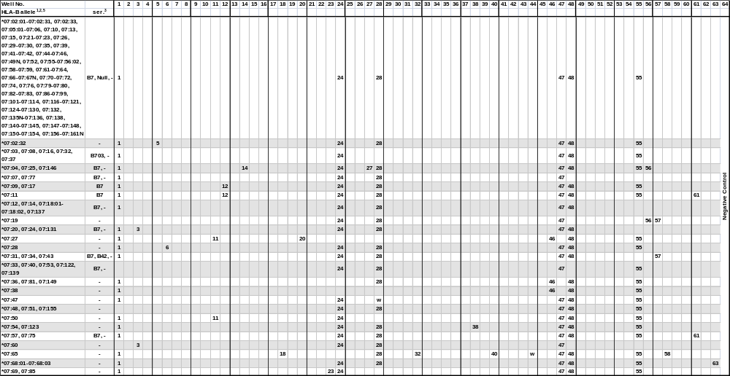
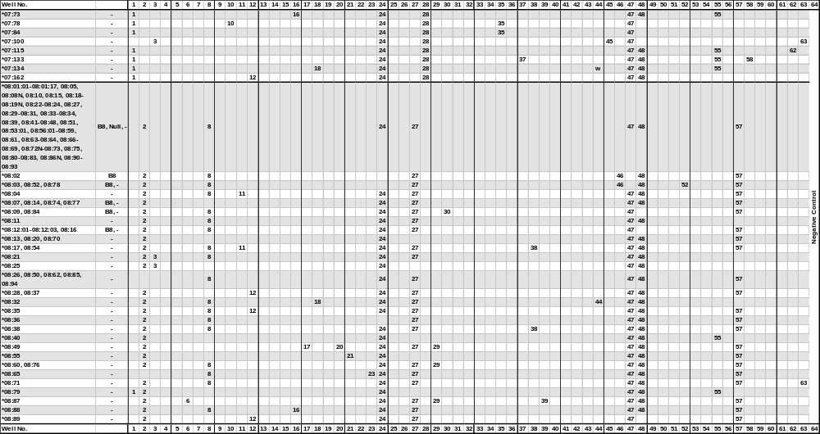
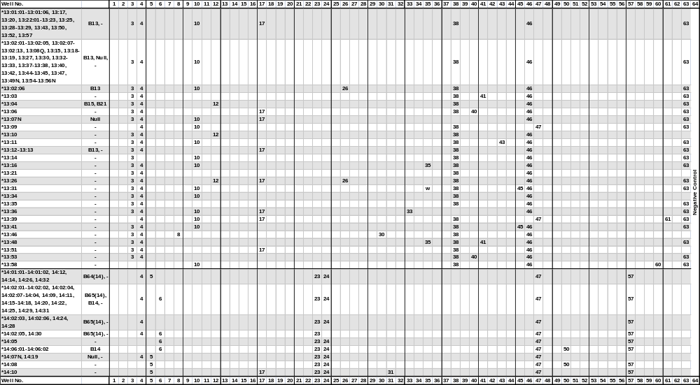
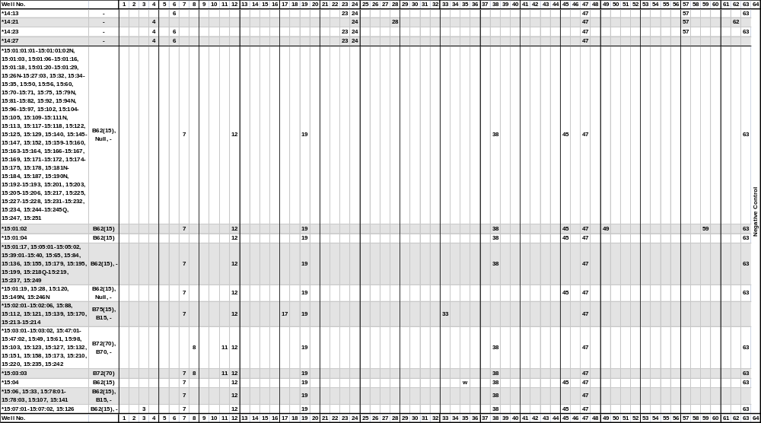
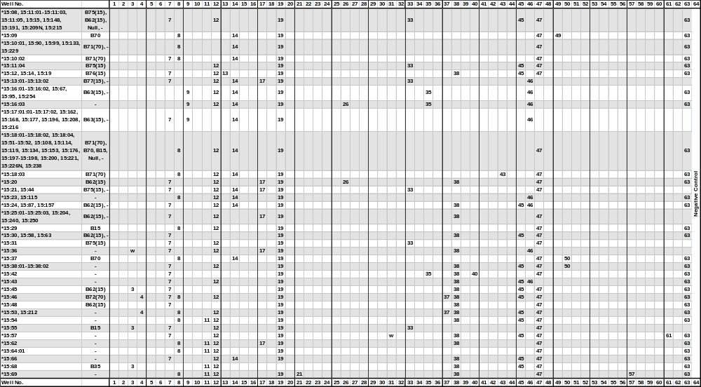
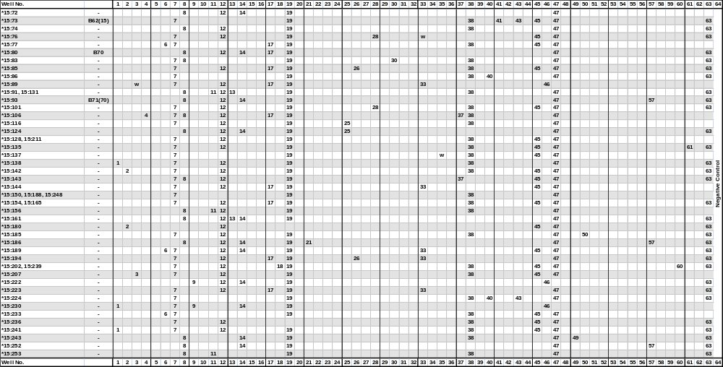
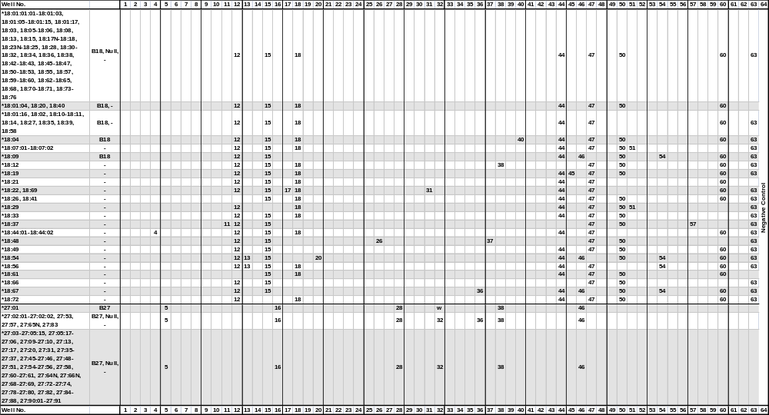
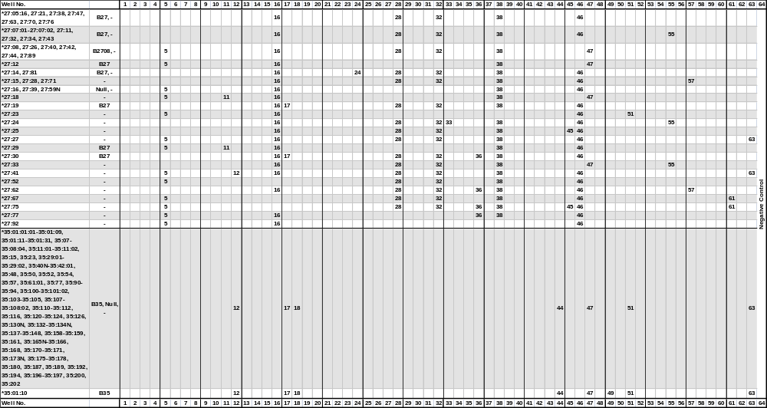
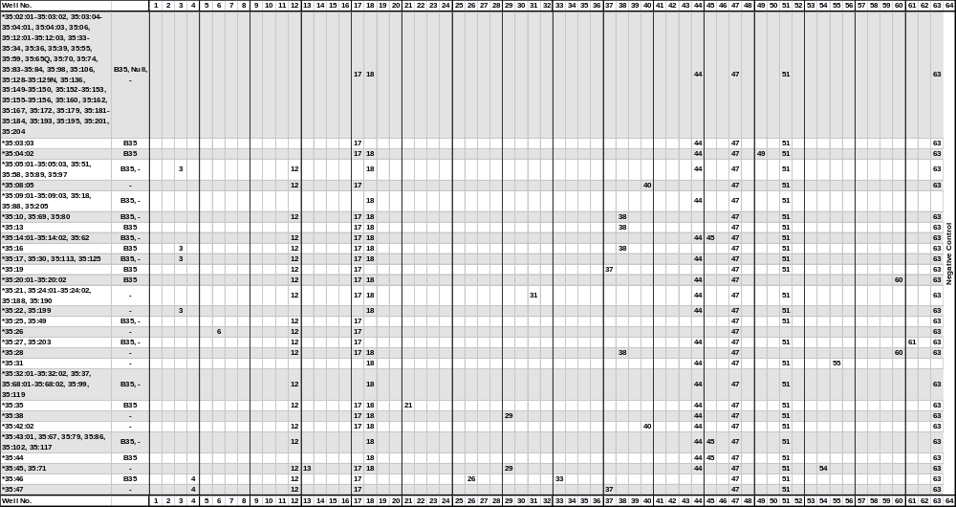
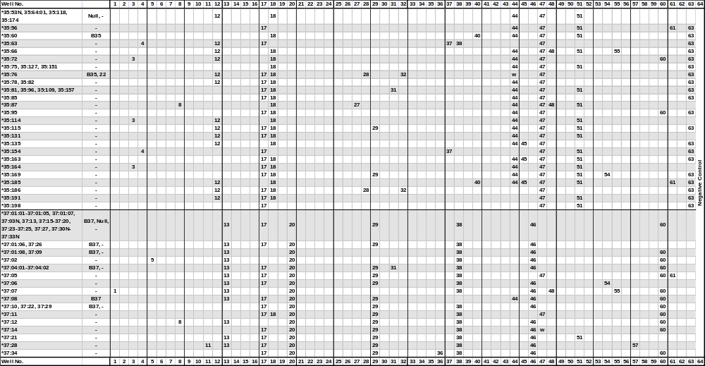
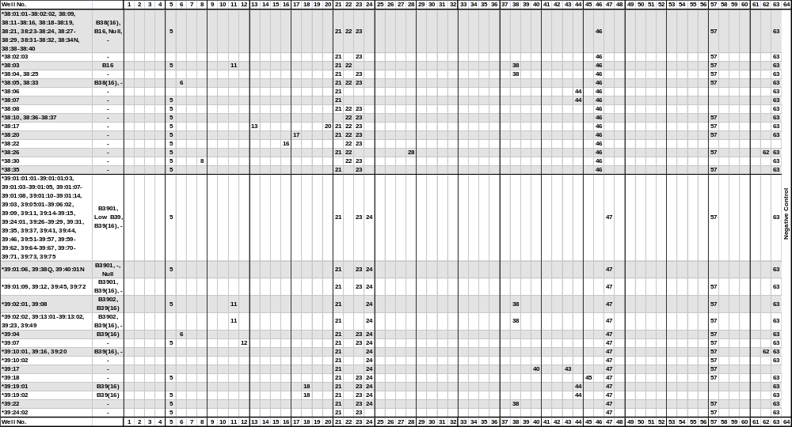
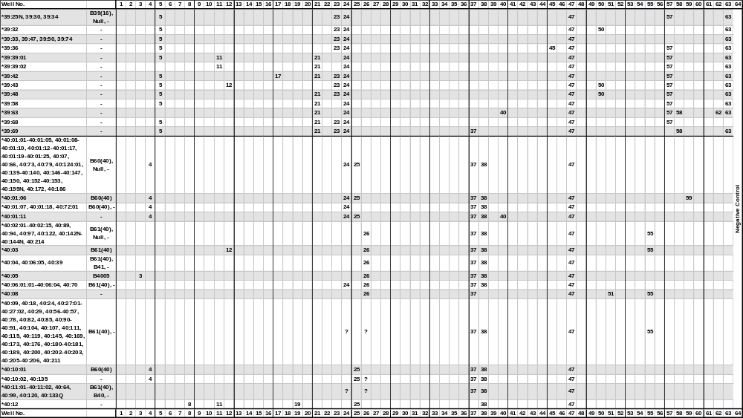
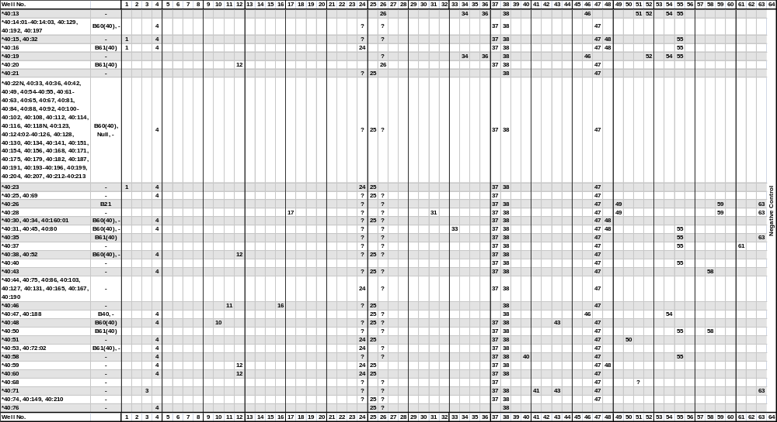
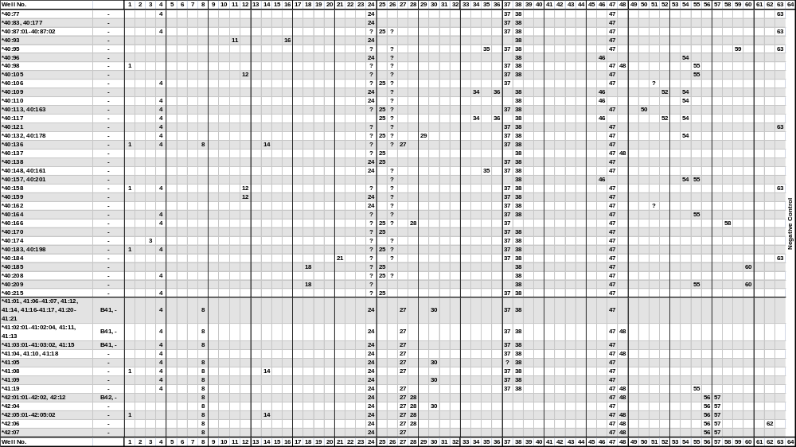
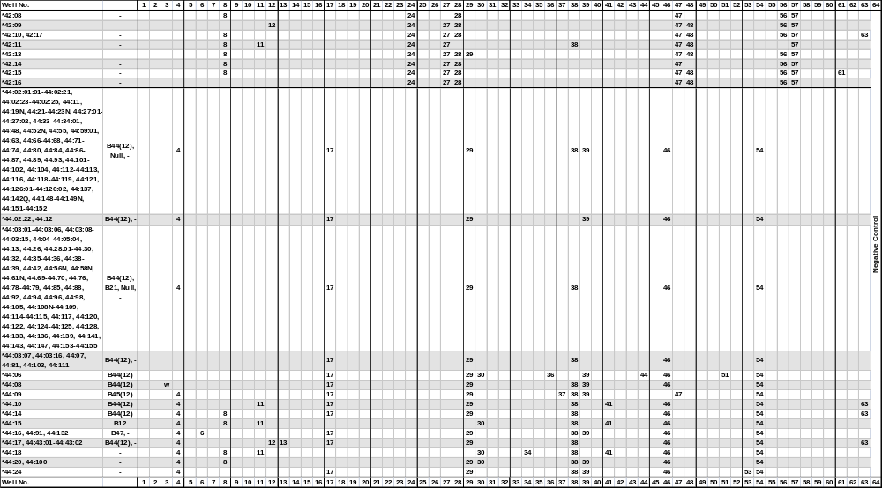
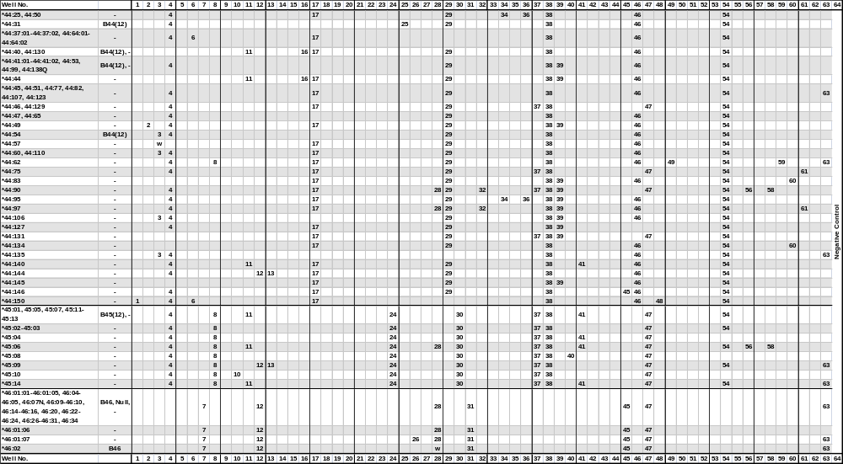
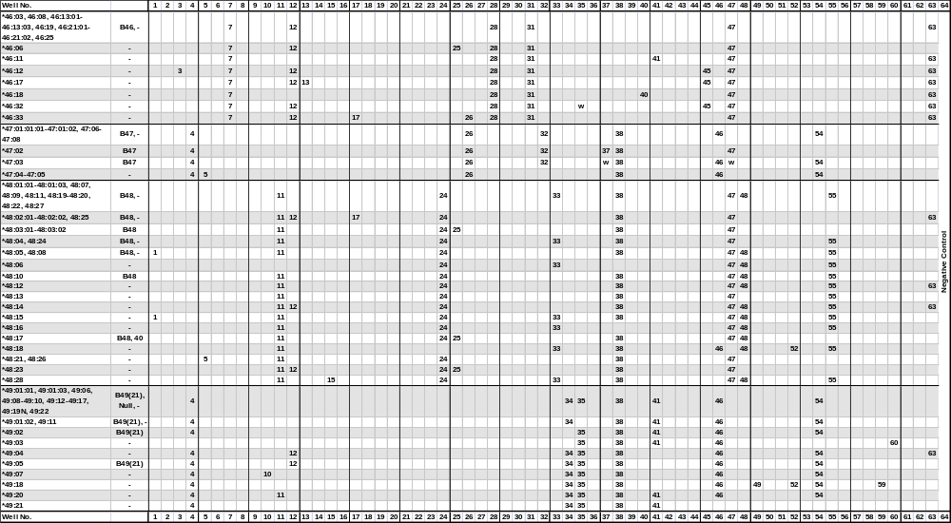
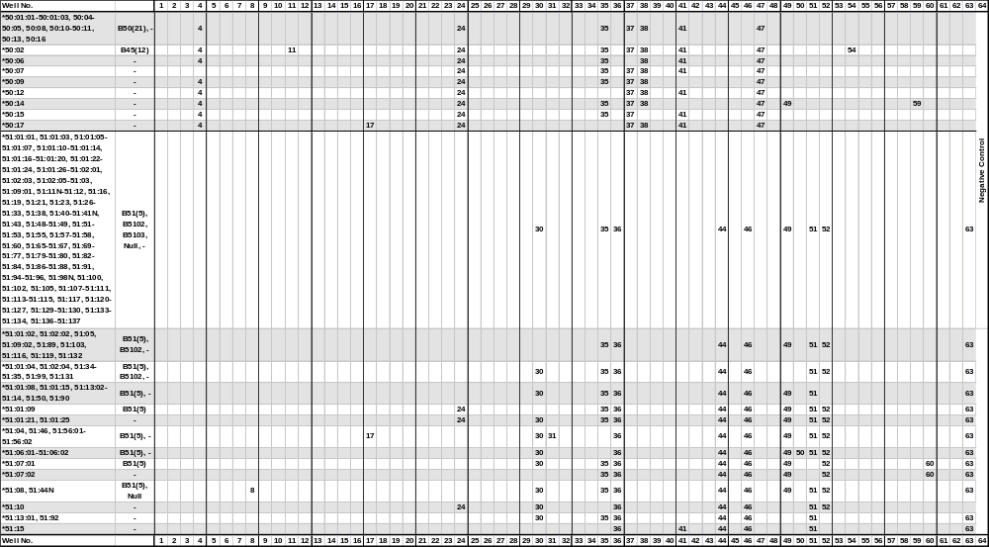
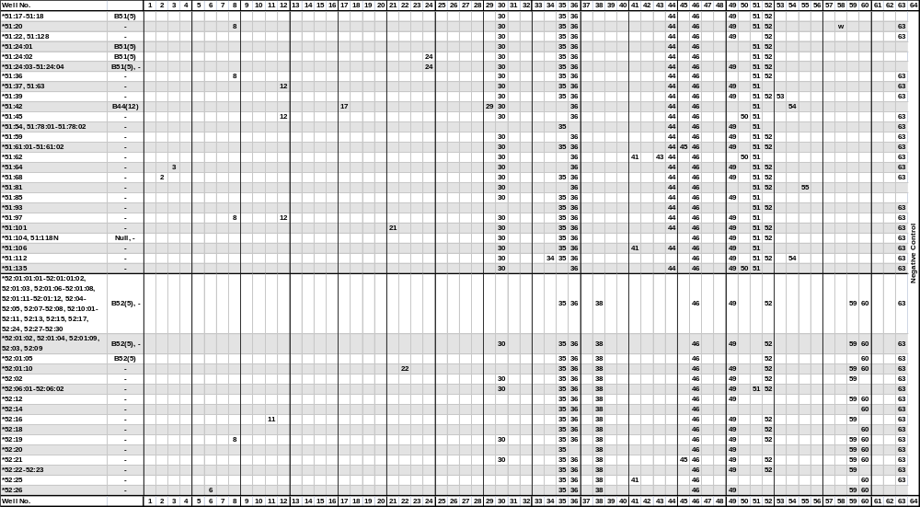
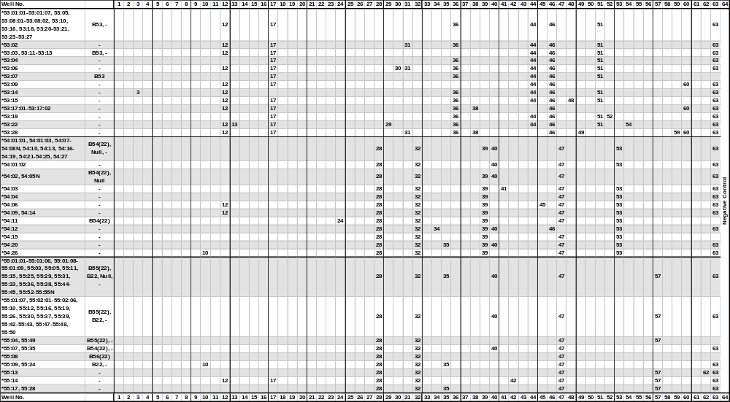
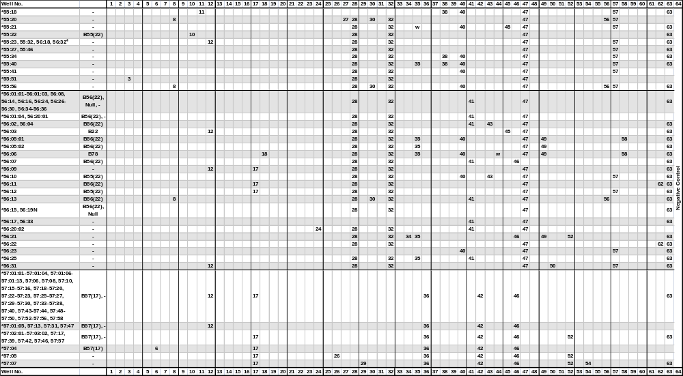
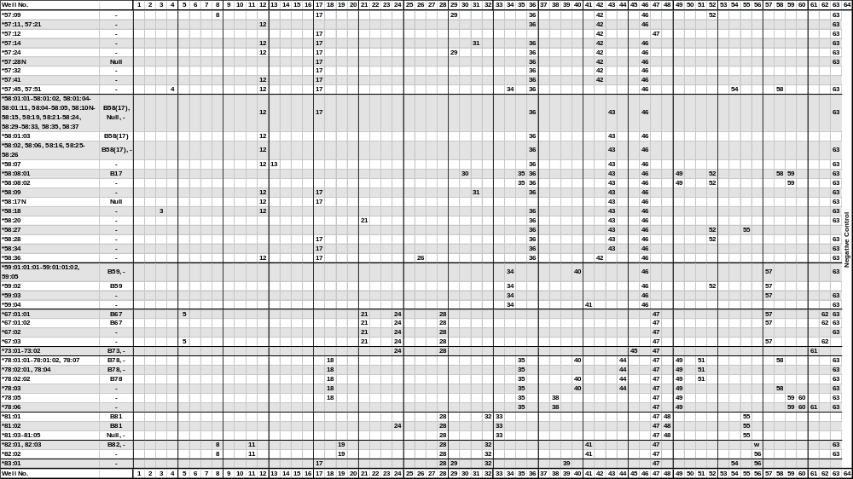
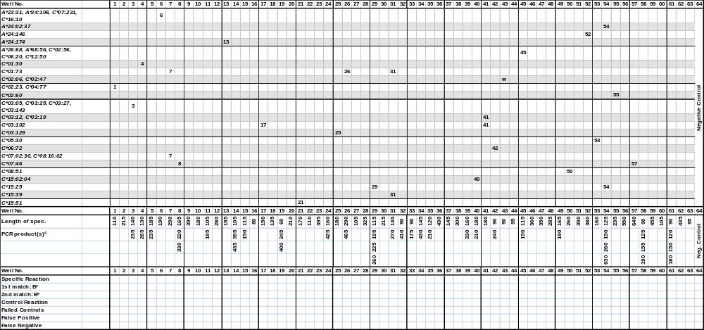

¹The sequence of the B*0701 allele has been shown to be in error.
The sequence of the B*08:06 allele has been shown to be identical to B*08:20.
The sequence of the B*1305 allele has been shown to be identical to B*13:04.
The B*1324 allele has been renamed B*13:22:02
The B*150105 allele has been corrected and renamed B*15:120
The B*1522 allele has been renamed B*35:43.
The sequence of the B*1541 allele has been shown to be identical to B*15:39.
The B*1559 allele has been renamed B*35:44.
The B*15:100 allele has never been assigned.
The sequence of the B*1816 allele has been shown to be identical to B*18:14.
The sequence of the B*27051 allele has been shown to be identical to B*27:05:02.
The sequence of the B*2722 allele has been shown to be identical to the corrected B*27:06 sequence.
The B*35:43:02 allele has been renamed B*35:185.
The B*3573 allele has been renamed B*35:08:03.
The sequence of the B*39012 allele has been shown to be identical to B*39:01:01:01.
The sequence of the B*3921 allele has been shown to be identical to B*39:24.
The sequence of the B*4017 allele has been shown to be identical to B*40:16.
The sequence of the B*4041 allele has been shown to be identical to B*40:40.
The sequence of the B*4203 allele has never been assigned.
The sequence of the B*4401 allele has been shown to be identical to B*44:02:01:01.
The sequence of the B*5003 allele has been shown to be identical to B*50:02.
The sequence of the B*5125 allele has been shown to be identical to B*51:22.
The B*5147 allele has been renamed B*51:09:02.
The sequence of the B*5506 allele has been shown to be identical to B*55:04.
The sequence of the B*5803 allele has never been assigned.
The B*7901 allele has been renamed B*15:18:01.
The B*9530 allele has been renamed B*15:27:02.
²The B*55:23 and 55:32 and the B*56:18 and 56:32 alleles give rise to identical amplification patterns with the HLA-B low resolution primer set. These alleles can be separated by the respective high resolution primer sets.
³The serological reactivity of all HLA-B alleles is not known. In this table we use the information in the HLA Dictionary 2004 on the www.ebi.ac.uk/imgt/hla web site and the expert-assigned serological grouping in Tissue Antigens (2009) 73:95-170.
⁴Primer mix 64 contains a negative control, which will amplify more than 95% of HLA amplicons as well as the amplicons generated by control primer pairs. PCR product sizes range from 75 to 200 base pairs. The PCR product generated by the control primer pair is 430 base pairs.
⁵Primer mix 4 amplifies the B*15:143, 35:19, 40:170, 44:07 and 50:07 alleles, and primer mix 26 amplifies the B*37:06:01 allele in addition to the alleles specified in the tables.

‘ser’, serological HLA specificity.
‘w’, might be weakly amplified.
‘?’, nucleotide sequence information not available for the primer matching sequence.

Change in revision R01 compared to R00:
- A footnote has been changed in the specificity table, as primer mix 57 has no known tendencies of giving rise to unspecific amplifications.
Change in revision R02 compared to R01:
- A duplicate page in the Interpretation Table has been removed.
Changes in revision R03 compared to R02:
- Primer mix 19 does not amplify the B*44:10 allele. This has been corrected in the Specificity and Interpretation Tables.
Changes in revision R04 compared to R03:
- In primer mixes 56 and 57, the specific PCR product may give rise to a lower yield of HLA-specific PCR product than the other HLA-B low primer mixes. A foot note has been added to the Specificity Table.
Change in revision R05 compared to R04:
- Primer mix 4 amplifies the B*15:143, 35:19, 40:170, 44:07 and 50:07 alleles, and primer mix 26 amplifies the B*37:06:01 alleles. Foot notes for these two primer mixes have been added to the Specificity Table.

